Thank you for your ongoing correspondence with the working group discussing name & role identification in operating theatres.

We would like to address the issues raised so far - namely infection risk and the level of support for name and role hats and propose a way forward.

**Infection risk**

There have been several trials performed comparing infection potential between reusable and disposable theatre hats (1,2,3). To date there is no evidence to indicate lesser infection rates with disposable compared to reusable theatre hats.

This is reflected in the collaborative statement from The American College of Surgeons (ACS), the American Society of Anesthesiologists (ASA), the Association of peri-Operative Registered Nurses (AORN), the Association for Professional in Infection Control and Epidemiology (APIC), the Association of Surgical Technologists (AST), the Council on Surgical and Perioperative Safety (CSPS) an The Joint Commission (TJC) released in February 2018 (4):

*‘At present, available scientific evidence does no demonstrate any association between the type of hat or extent of hair coverage and SSI rates. One recent study on head coverings (disposable bouffant or skullcap, cloth cap), identified that the commonly available bouffant hat is the least effective barrier to transmission of particles (5).’*

Further the Australian and New Zealand College of Anaesthetists in its Statement on Environmental Sustainability in Anaesthesia (ANZCA PS64) has come down in favour of reusable hats because of their cost saving and reduction in environmental waste (6):

*‘Use of reusable freshly laundered lint free hats will reduce the amount of single use caps that are discarded and add to waste.’*

**Level of support for name and role theatre hats**

Survey analysis has indicated that name and role identification is extremely well supported by patients.

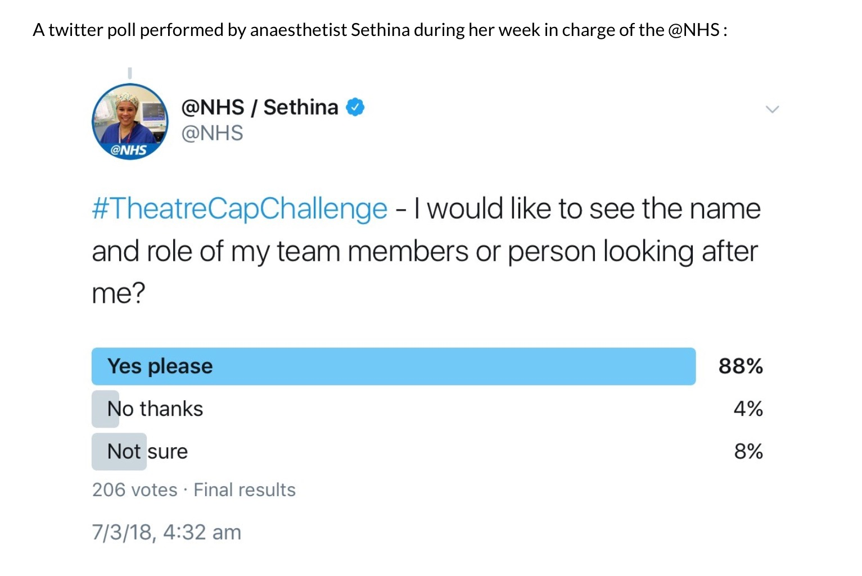

Similarly a soon to be published survey of over 1000 people - the majority healthcare staff - has shown similar levels of support for name and role theatre caps.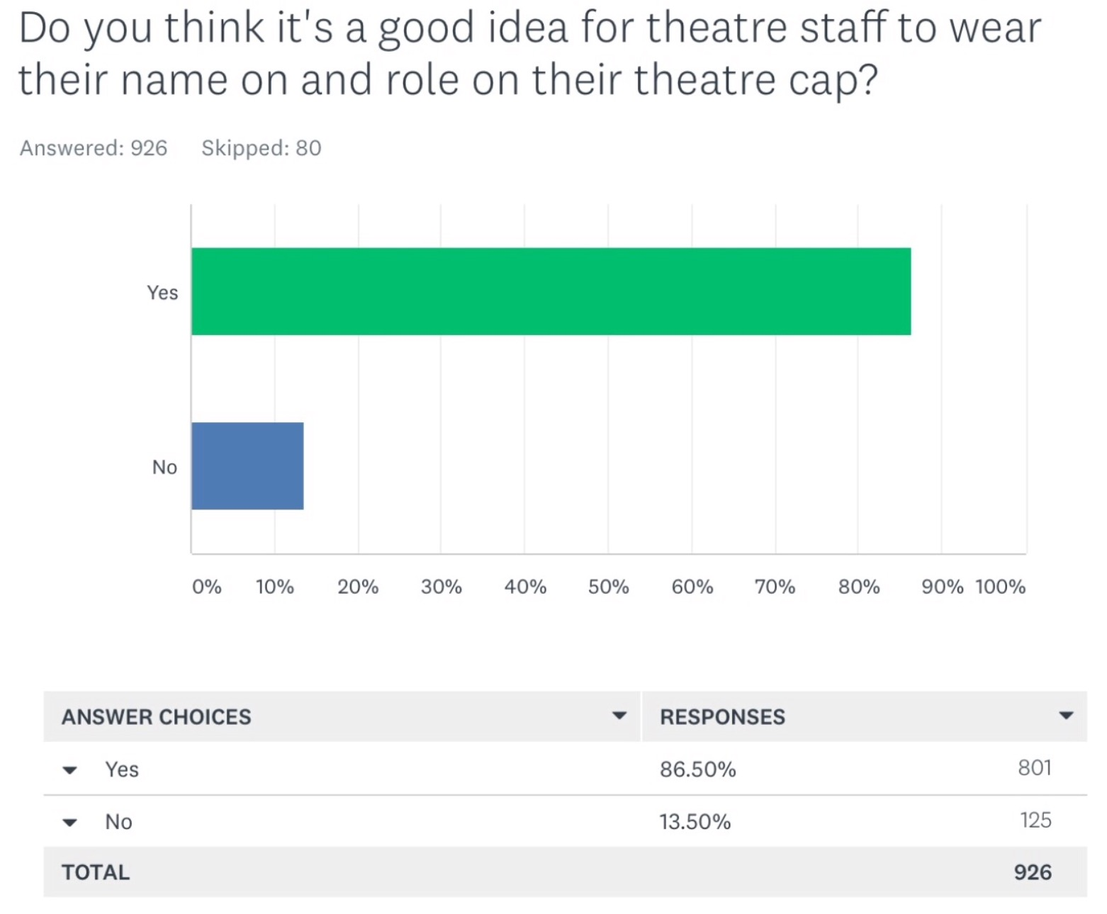

Interestingly and perhaps understandably there is a discrepancy in where this support comes from. Nursing and medical students surveyed provided overwhelming support:

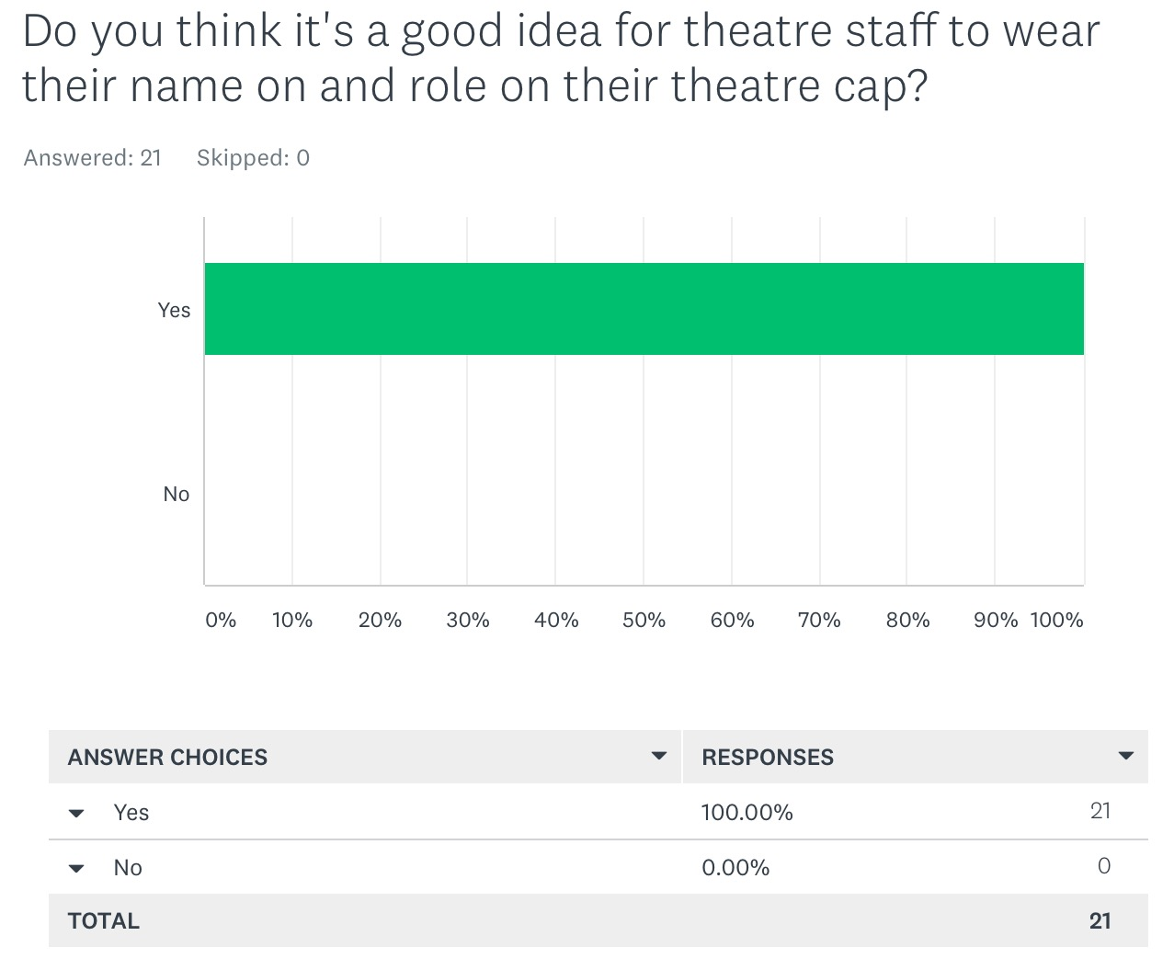

Compare this with surgeons who have worked in healthcare for more than 20 years: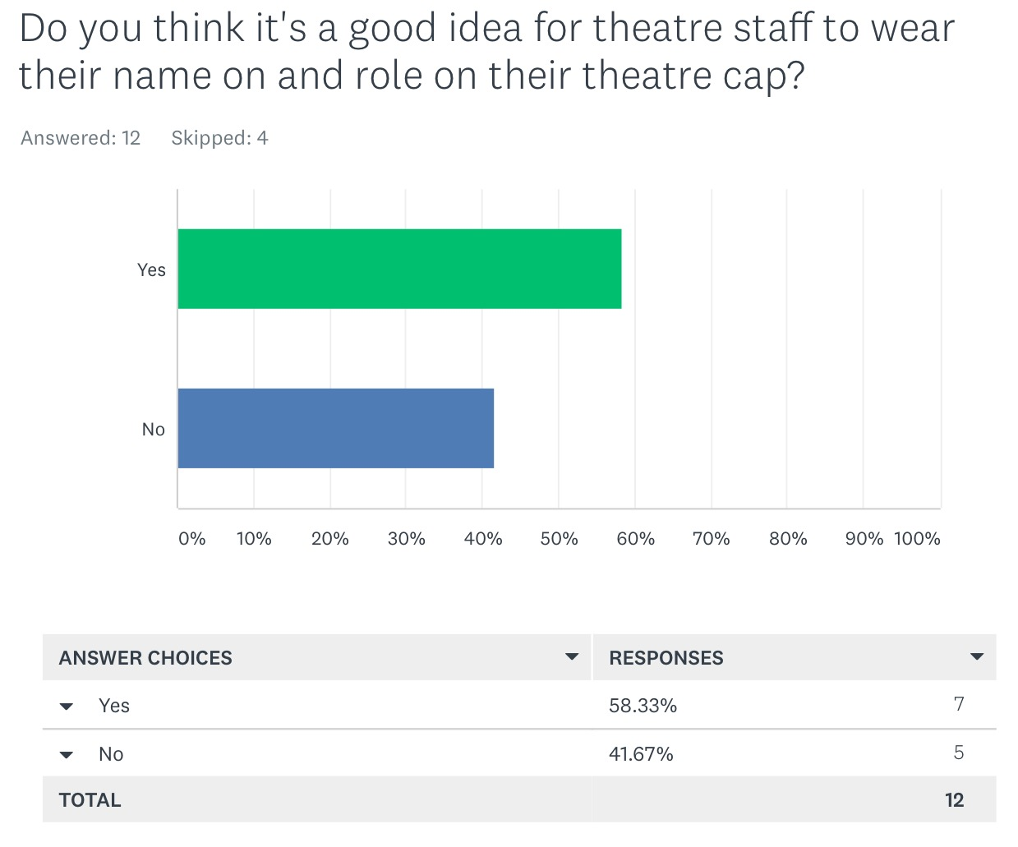

Unfortunately those who have worked in healthcare the longest often hold the balance of power and despite overwhelming support for the initiative command structures of management are able to prevent it being implemented. Communication within theatre suffers as a result.

Name and role theatre hats are well supported by theatre staff. Many staff will feel comfortable wearing them though seeing others wearing them.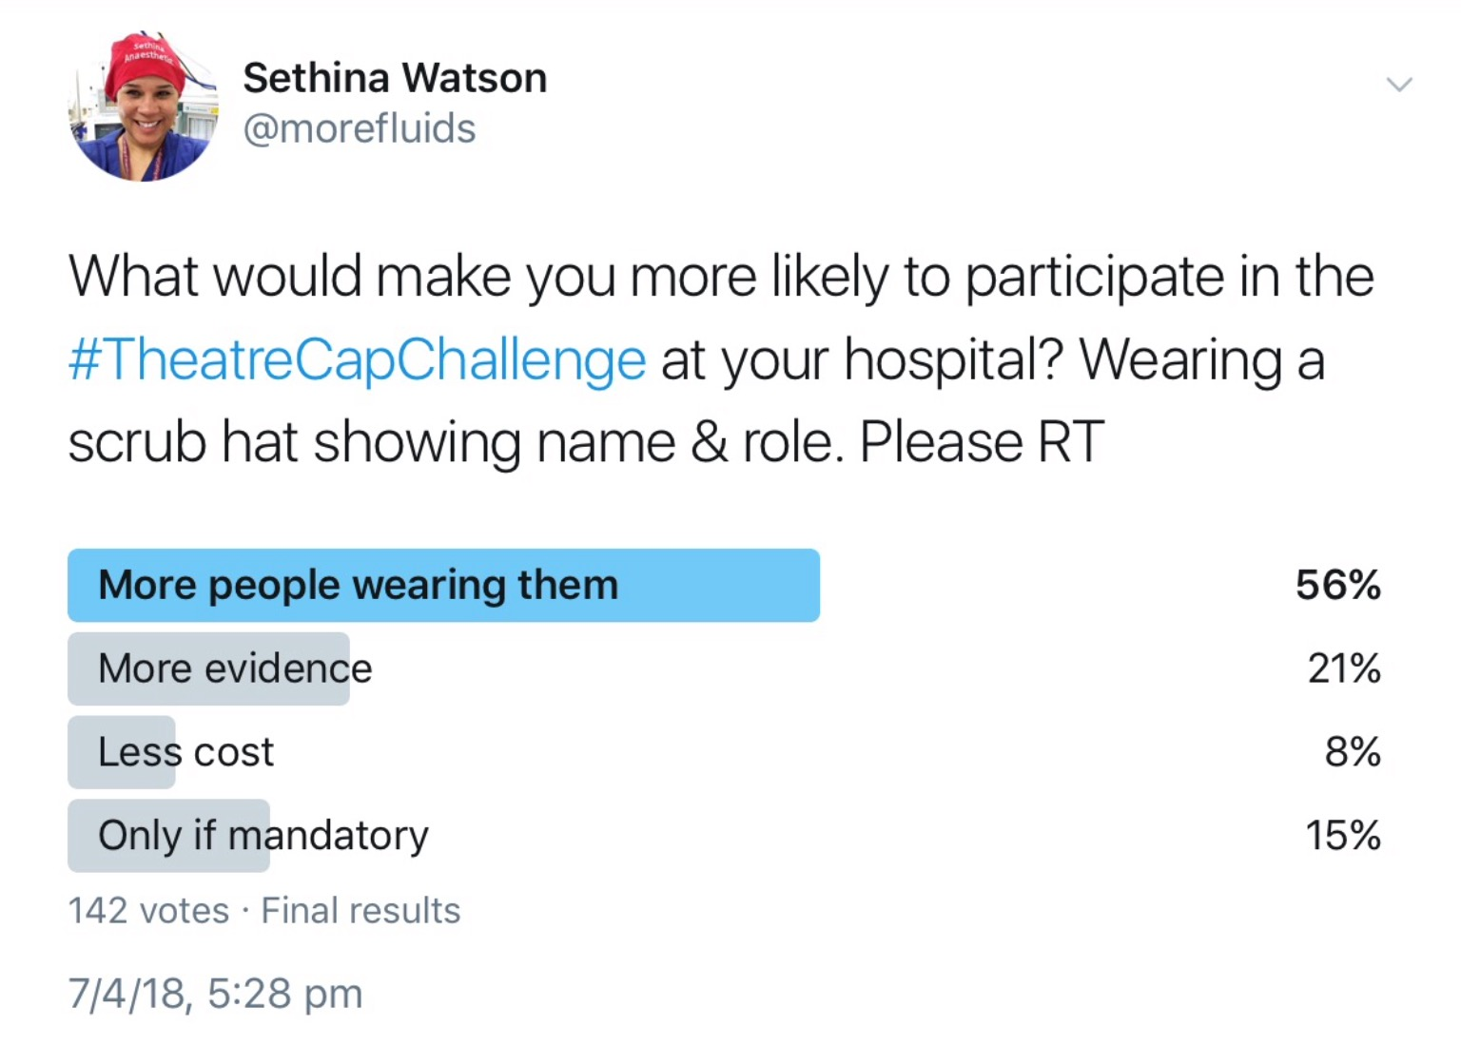

Many of those who don't wear them at present are concerned about doing so because they are aware of the opinions of authority figures within the hospital and believe that doing so might upset them.

Perhaps those who would be least likely to benefit from wearing name & role theatre hats would be consultant surgeons - data demonstrates that of all staff in theatre their names and roles are best known (13). However for those surgeons who choose to it would help create an environment where others would feel more comfortable doing the same. This would enhance the non-technical skills of the surgeon through improving their recall of the names and roles of staff they are working with.

At present within most theatre environments the overwhelming majority of staff have no visible means of identification. This is of significant detriment to communication and team work which may negatively impact on patient outcomes. This also goes against the recommendations of the Garling Enquiry 2008 (7):

*NSW Health amend existing policy or develop additional policy to require the wearing of name badges (or similar, but not cards on lanyards) by each type of health professional bearing in large print the person's name and title or role.*

and the subsequent brochure produced by NSW Government (8):

*Knowing the name of the nurse, midwife, doctor and allied health worker just makes communication between patients and staff easier. The nurse/midwife in charge will ensure that all staff are easily identifiable.*

To many the benefits of name and role theatre hats as a communication tool throughout the working day are already very obvious. We are a mobile workforce coming together at different locations for brief periods as transient teams throughout the day.

Some of the statistical analysis behind this initiative make the benefits even more apparent:

Communication errors have been implicated as the root cause of nearly 70% of adverse events (9). Further studies have demonstrated communication failures occur in approximately 30% of theatre team exchanges and a third of these have immediate effects such as causing inefficiency and tension (10).

Theatre staff are extremely poor at completing the name & role introduction part of the Team Time Out (11).

Even when not distracted humans only recall 30% of names after first introduction and then we readily forget them (12).

Even when the team time out introduction has been appropriately performed at the start of a case then name recall is still poor at the end of the case. In one study 25% of surgeons did not know the scrub nurses name and 30% of surgeons did not know the anaesthetists name (13).

The chances of attending an emergency with the exact same staff as on a previous occasion can be in the millions: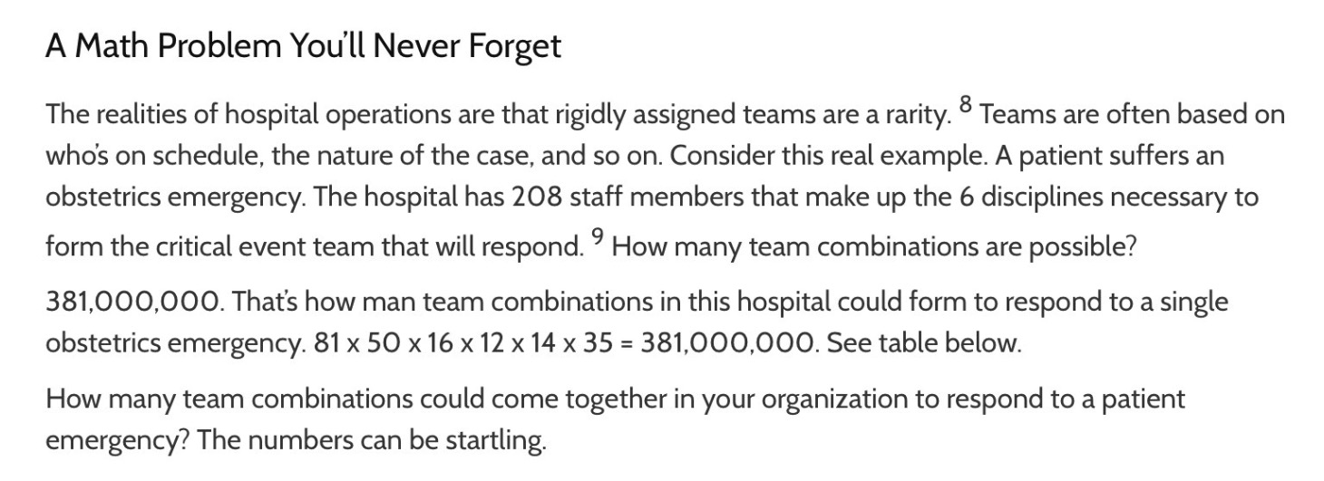

Knowing and recognising team members by name has been quantitatively and qualitatively associated with increased trust, work engagement and clinical improvement (14).

The information supporting name and role hats continues to be gathered by a large and well renowned international collaborative team who are passionate about patient safety (15).

It is understandable that simple initiatives like name and role theatre hats can be difficult to stomach (given we perhaps should have adopted them a long time ago) when compared with the new and complex. However to continue to resist them only continues to put our patients at unnecessary risk.

It is these simple initiatives, which make our work interfaces less complex, which will create the greatest gains for patient safety - there are many more we could collaborate on and consider introducing given the right support.

We note that several trusts in the NHS UK have adopted name and role theatre hats wholeheartedly to the extent they have funded hats for their theatre staff.

While this is not something we would expect all institutions to fund it would be a shame to see our hospital lag behind others in adopting this patient safety initiative - an initiative which has increasing international resonance.

Further supporting this intervention will send a strong signal that the initiatives of front line staff are well supported and where appropriate can be facilitated to generate the optimal environment for patient care.

We accept that wearing name and role hats would not be to everyone's tastes and believe this initiative should be entirely voluntary. However at present we feel it is not - staff concerned about doing something they don't feel is supported by senior staff. It is in this light we look to promote the benefits of staff identification and to let others know that name and role theatre hats are welcomed on a voluntary basis.

**References**

1. <https://academic.oup.com/neurosurgery/article-abstract/82/4/548/3786415?redirectedFrom=fulltext>
2. <https://link.springer.com/epdf/10.1007/s10029-017-1626-7?shared_access_token=MsAyNARXqFL3AdC90JXs5Pe4RwlQNchNByi7wbcMAY4HuL8SBKMKNuClKHkgRjTPGSrGVDZ7UyBAVuurh3XlfEb7Vmv4DriwU3oYDRL9n66pjoKVSub_qV9c4xx6jJMNO21MM2EO5bwJYKFR5uvLybhuhMnGlB-6A74NBkHRe3A%3D>
3. <http://www.journalacs.org/article/S1072-7515(18)30036-X/abstract>
4. <http://www.asahq.org/~/media/sites/asahq/files/public/advocacy/alerts/washington%20alerts/2018-4-27-or-attire-consensus-statement.pdf?la=en>
5. <https://www.psnetwork.org/wp-content/uploads/2018/01/ACS-2017.ppt>
6. <https://www.psnetwork.org/wp-content/uploads/2018/03/PS64-Statement-on-Environmental-Sustainability-in-Anaesthesia-and-Pain-Medicine-Practice-022018-Pilot.pdf>
7. <https://www.psnetwork.org/wp-content/uploads/2018/06/Overview-Special-Commission-of-Inquiry-into-Acute-Care-Services-in-NSW.pdf>
8. https://www.psnetwork.org/wp-content/uploads/2018/06/caring-together-plan.pdf
9. <https://www.ncbi.nlm.nih.gov/books/NBK143239/#!po=7.14286>
10. https://qualitysafety.bmj.com/content/qhc/13/5/330.full.pdf
11. <https://www.ncbi.nlm.nih.gov/pmc/articles/PMC4544783/>
12. <https://www.spring.org.uk/2011/12/why-peoples-names-are-so-hard-to-remember.php>
13. <https://i1.wp.com/www.psnetwork.org/wp-content/uploads/2018/01/IMG_4963.jpg?ssl=1>
14. <https://www.psnetwork.org/wp-content/uploads/2018/02/Acad-Emerg-Med-2017.pdf>
15. https://www.psnetwork.org/theatrecapchallenge-wheres-the-evidence/